

**SQL Assignment**

**By: Yuaan Hussain**



[www.linkedin.com/in/muneer-ahmed-quadri](http://www.linkedin.com/in/muneer-ahmed-quadri)

**#**

**4**

**I**

**R**

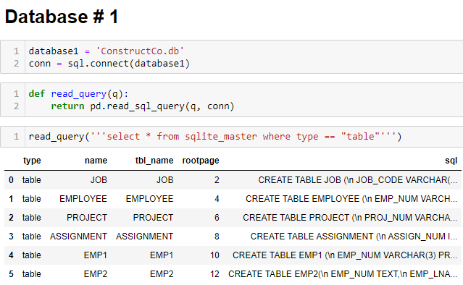

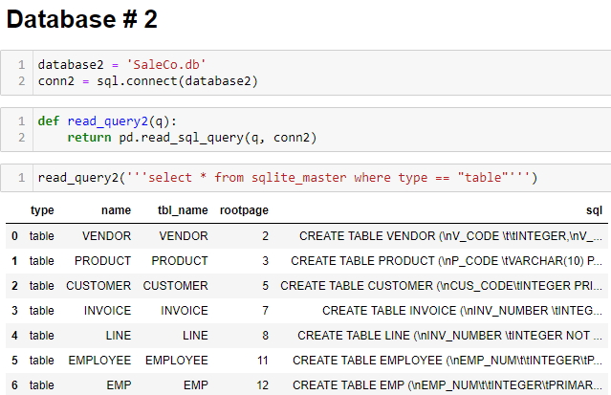

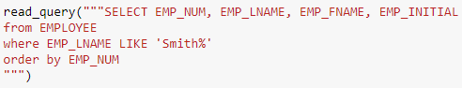P1. Write the SQL code required to list the employee number, last name, first name, and middle initial of all employees whose last names start with Smith. In other words, the rows for both Smith and Smithfield should be included in the listing. Sort the results by employee number. Assume case sensitivity.

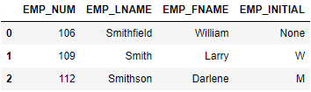

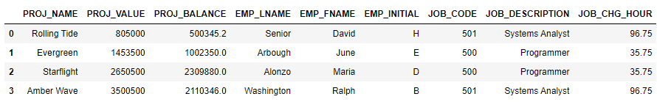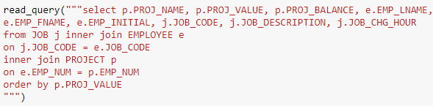P2. Using the EMPLOYEE, JOB, and PROJECT tables in the ConstructCo database, write the SQL code that will join the EMPLOYEE and PROJECT tables using EMP NUM as the common attribute. Display the attributes shown in the results presented in Figure 2, sorted by project value.

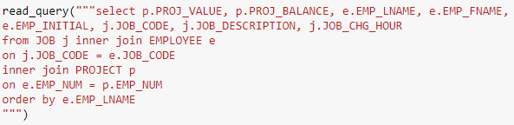P3. Write the SQL code that will produce the same information that was shown in Problem P2., but sorted by the employee’s last name.

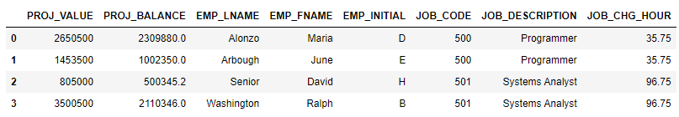

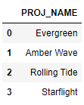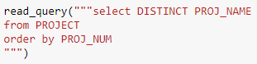P4. Write the SQL code that will list only the distinct project numbers in the ASSIGNMENT table, sorted by project number.

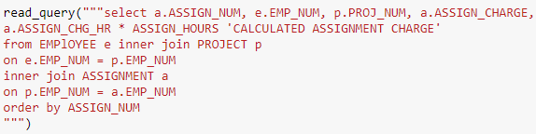P5. Write the SQL code to validate the ASSIGN CHARGE values in the ASSIGNMENT table. Your query should retrieve the assignment number, employee number, project number, the stored assignment charge (ASSIGN CHARGE), and the calculated assignment charge (calculated by multiplying ASSIGN CHG HR by ASSIGN HOURS). Sort the results by the assignment number.

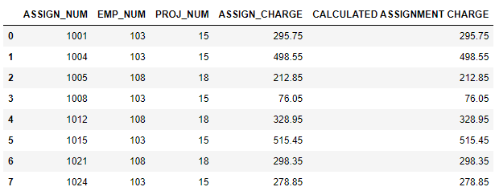

P6. Using the data in the ASSIGNMENT table, write the SQL code that will yield the total number of hours worked for each employee and the total charges stemming from those hours worked,

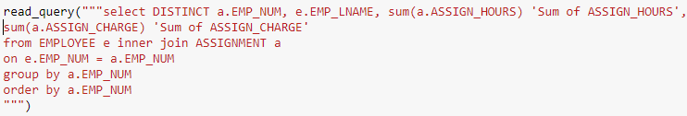sorted by employee number. The results of running that query are shown in Figure 3.

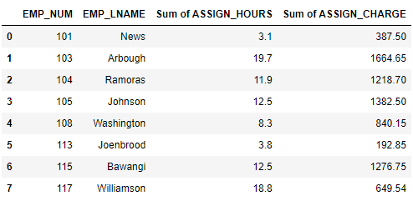

P7. Write a query to produce the total number of hours and charges for each of the projects represented in the ASSIGNMENT table, sorted by project number. The output is shown in

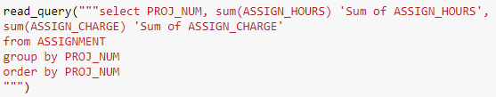Figure 4.

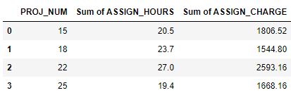

P8. Write the SQL code to generate the total hours worked and the total charges made by all employees. The results are shown in Figure 5.

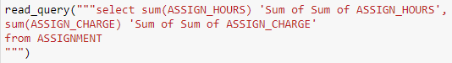

P9. Write a query to count the number of invoices.



P10. Write a query to count the number of customers with a balance of more than $500.



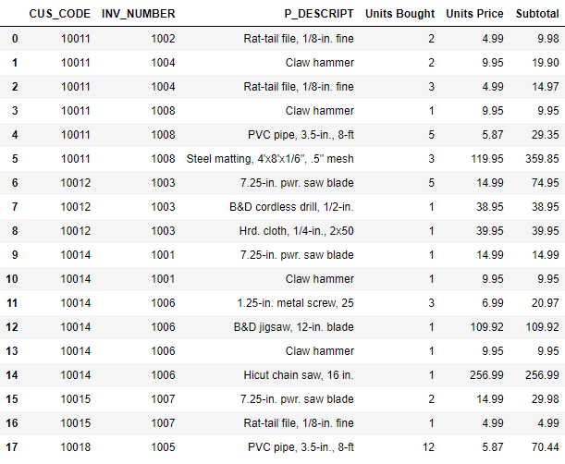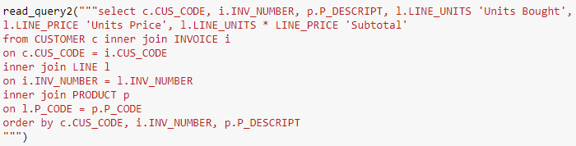P11. Using the output shown in Figure 7 as your guide, generate a list of customer purchases, including the subtotals for each of the invoice line numbers. The subtotal is a derived attribute calculated by multiplying LINE UNITS by LINE PRICE. Sort the output by customer code, invoice number, and product description. Be certain to use the column aliases as shown in the figure.

P12. Write a query to display the customer code, balance, and total purchases for each customer. Total purchase is calculated by summing the line subtotals (as calculated in Problem P11.) for each customer. Sort the results by customer code, and use aliases as shown in

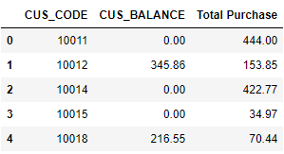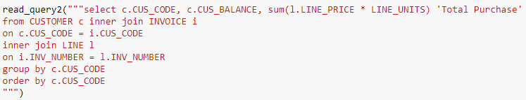Figure 8.

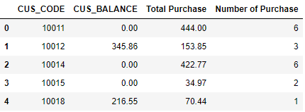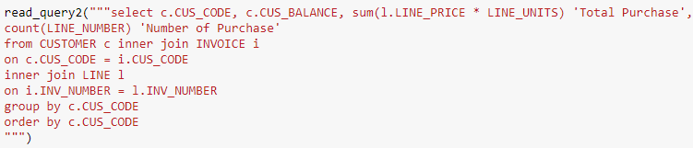P13. Modify the query in Problem P12. to include the number of individual product purchases made by each customer. (In other words, if the customer’s invoice is based on three products, one per LINE NUMBER, you count three product purchases. Note that in the original invoice data, customer 10011 generated three invoices, which contained a total of six lines, each representing a product purchase.) Your output values must match those shown in Figure 9, sorted by customer code.

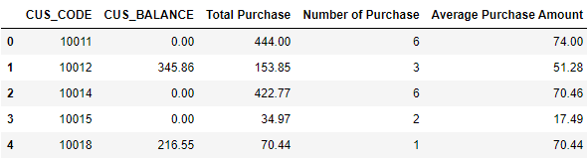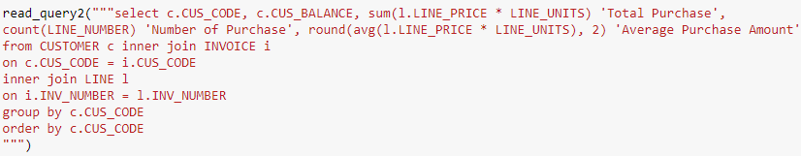P14. Use a query to compute the total of all purchases, the number of purchases, and the average purchase amount made by each customer. Your output values must match those shown in Figure 10. Sort the results by customer code.

P15. Create a query to produce the total purchase per invoice, generating the results shown in Figure 11, sorted by invoice number. The invoice total is the sum of the product purchases in the LINE that corresponds to the INVOICE.

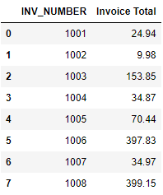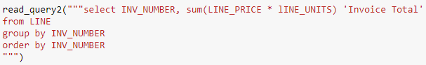

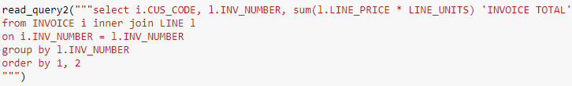P16. Use a query to show the invoices and invoice totals in Figure 12. Sort the results by customer code and then by invoice number.

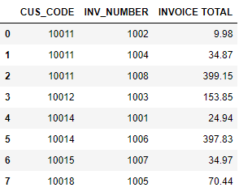

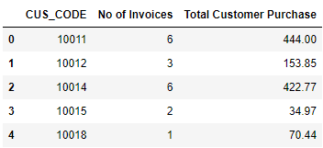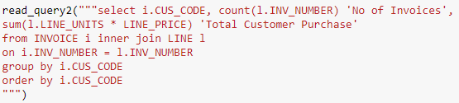P17. Write a query to produce the number of invoices and the total purchase amounts by customer, using the output shown in Figure 13 as your guide. Note the results are sorted by customer code. (Compare this summary to the results shown in Problem P16..)

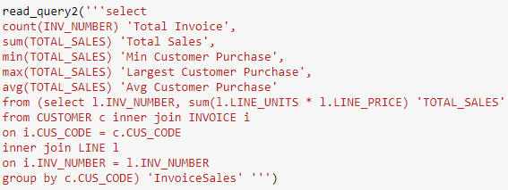P18. Write a query to generate the total number of invoices, the invoice total for all of the invoices, the smallest of the customer purchase amounts, the largest of the customer purchase amounts, and the average of all the customer purchase amounts. Your output must match Figure 14.

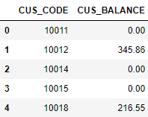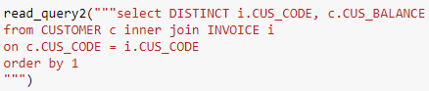P19. List the balances of customers who have made purchases during the current invoice cycle – that is, for the customers who appear in the INVOICE table. The results of this query are shown in Figure 15, sorted by customer code.

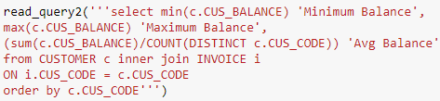P20. Provide a summary of customer balance characteristics for customers who made purchases. Include the minimum balance, maximum balance, and average balance, as shown in Figure 16.

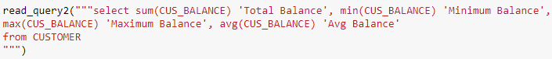P21. Create a query to find the balance characteristics for all customers, including the total of the outstanding balances. The results of this query are shown in Figure 17.

P22. Find the listing of customers who did not make purchases during the invoicing period. Sort the results by customer code. Your output must match the output shown in Figure 18.

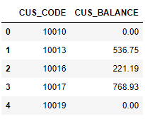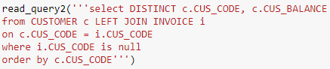

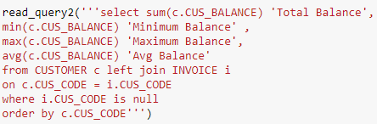P23. Find the customer balance summary for all customers who have not made purchases during the current invoicing period. The results are shown in Figure 19.



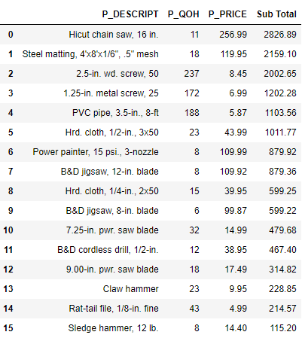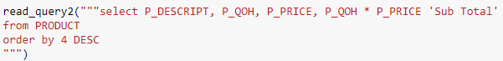P24. Create a query that summarizes the value of products currently in inventory. Note that the value of each product is a result of multiplying the units currently in inventory by the unit price. Sort the results in descending order by subtotal, as shown in Figure 20.

P25. Find the total value of the product inventory. The results are shown in Figure 21.

